SF.SmokeTestScripts_TC_SF_OBRequiredFieldsOnSalesStage_Instance1_12-Apr-2017_05-03-21_PM_Invoke_Application.png



SF.SmokeTestScripts_TC_SF_OBRequiredFieldsOnSalesStage_Instance1_12-Apr-2017_05-03-30_PM_Login.png

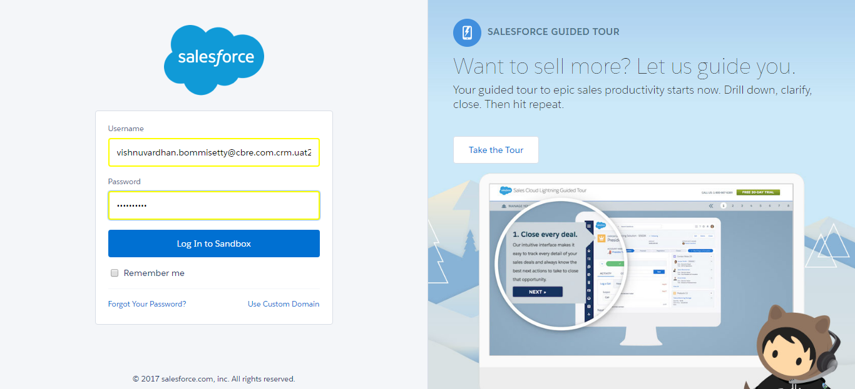

SF.SmokeTestScripts_TC_SF_OBRequiredFieldsOnSalesStage_Instance1_12-Apr-2017_05-03-43_PM_Verify_Login.png

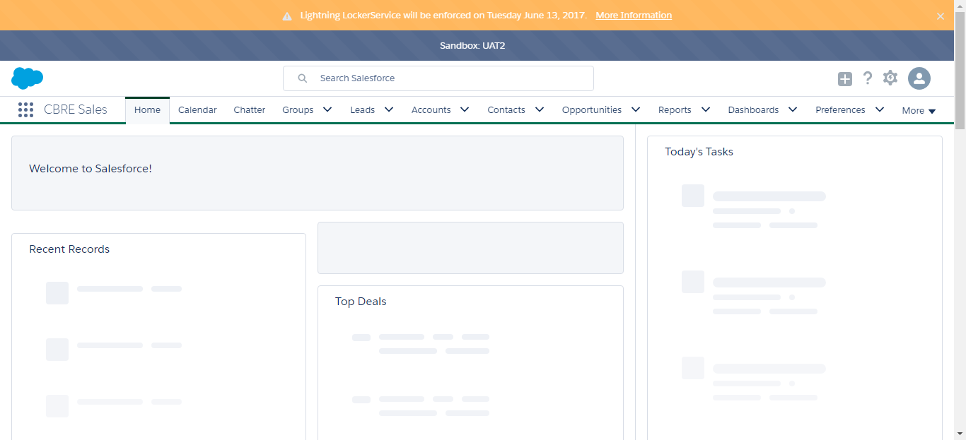

SF.SmokeTestScripts_TC_SF_OBRequiredFieldsOnSalesStage_Instance1_12-Apr-2017_05-03-45_PM_Verify_Fetch_Record.png

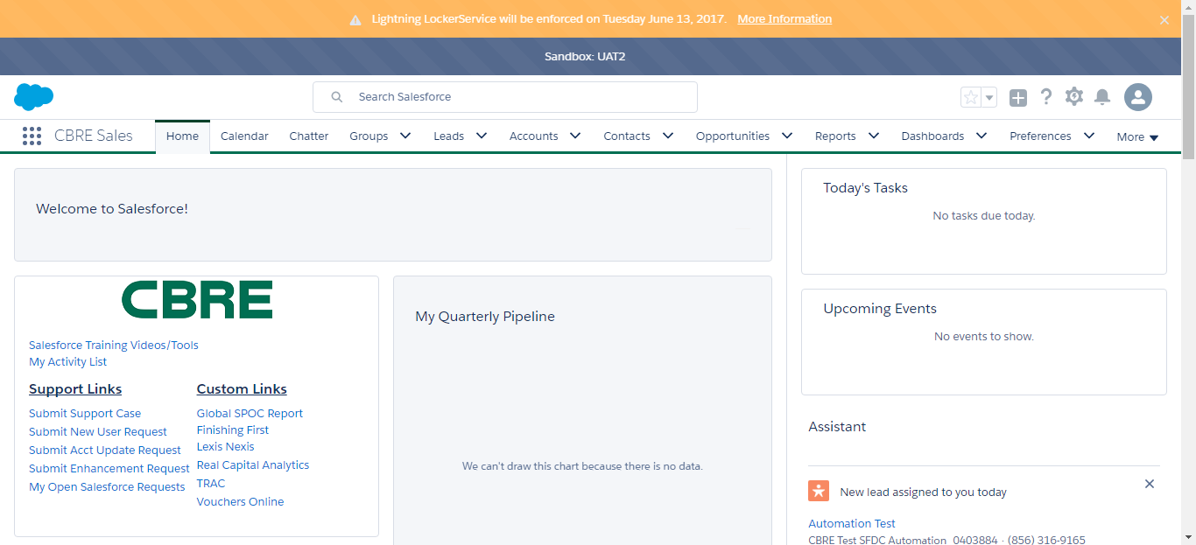

SF.SmokeTestScripts_TC_SF_OBRequiredFieldsOnSalesStage_Instance1_12-Apr-2017_05-03-50_PM_Verify_Opportunity_Required



SF.SmokeTestScripts_TC_SF_OBRequiredFieldsOnSalesStage_Instance1_12-Apr-2017_05-03-51_PM_Verify_Add_Opportunity_Page



SF.SmokeTestScripts_TC_SF_OBRequiredFieldsOnSalesStage_Instance1_12-Apr-2017_05-04-13_PM_Verify_Add_Opportunity_Page

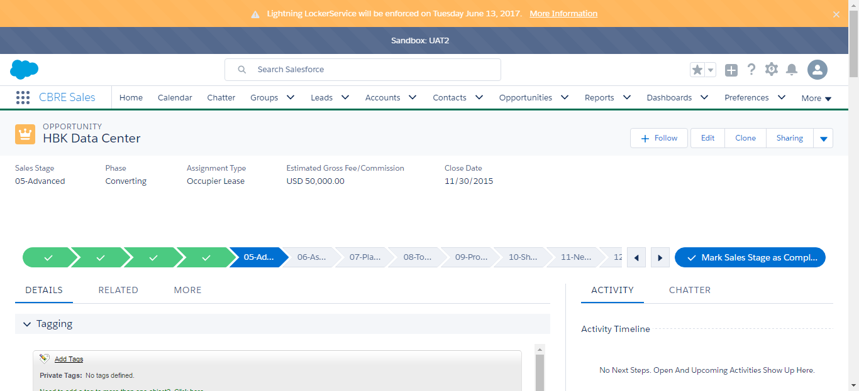

SF.SmokeTestScripts_TC_SF_OBRequiredFieldsOnSalesStage_Instance1_12-Apr-2017_05-05-10_PM_Error.png

